1.1.2 Solving differential equations with Euler forward Now, try to solve the ODE using Euler forward with a step size dt = 0.05. Plot the solution and compare with the ode45 solution. • Increase and decrease the step size, dt. Test for example dt = {0.01, 0.1} What happens? Why?

**Mindre precis, färre punkter. Höga dt 🡪 kantig och förlora form**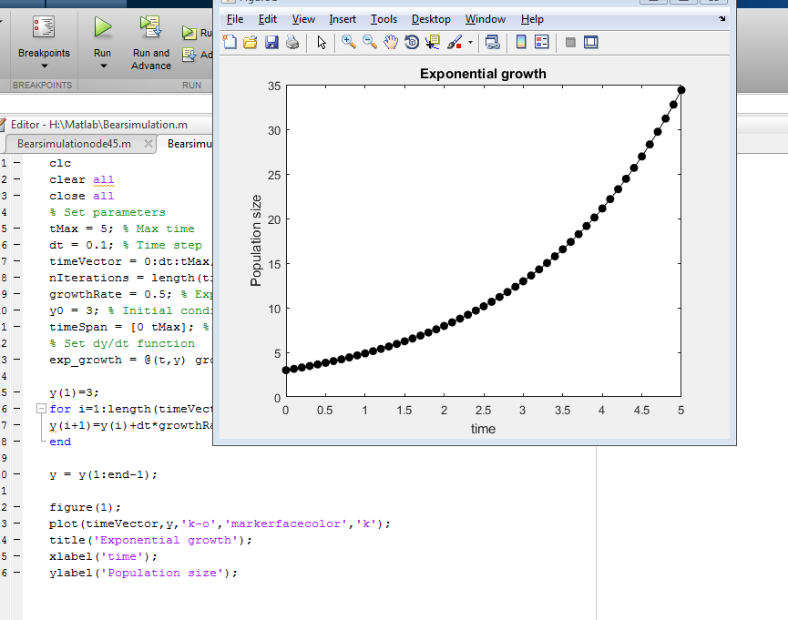

• Increase and decrease the growth rate, growthRate. Test for example growthRate = {0.1, 0.8}. What happens? Why?

**Populationsförändringen av antalet individer accelererar. Med mindre growthRate accelererar detta långsammare. Med negativt konvergerar den mot 0.**

1.1.3 Doubling time Compute the time it takes until the bacteria population has doubled its initial size and plot together with the solution curves.

När pop = 2y0

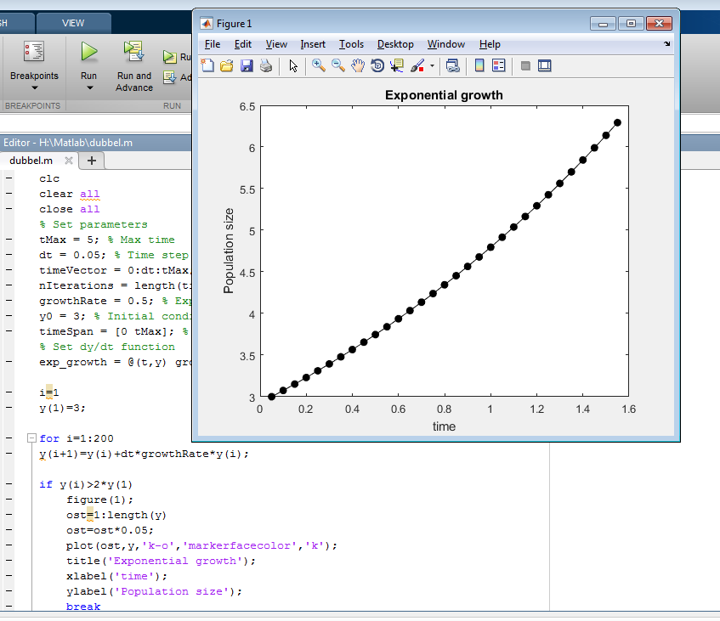

1.1.4 Time delay Suppose that we want to model the population size of mice. One then has to take a maturation period into account. This is done by including a delay from the time a new individual is born until it can reproduce as seen in Equation (2). dy dt = r · y(t − τ ) (2) Solve the time delay differential equation in Equation (2) with Euler forward and τ = 1 and compare with MATLAB built-in function dde23. Use the same growth rate and y0 as in Task 1.1. Suppose that we know how the population size evolved before t = 0 and use a history function f0(t) = y0e r2t , with r2 = 0.3 when solving for t ∈ [0, τ ). Plot the solution together with the two ODE solutions in 1.1. What is the difference? Why?